  - Teaching and Learning in Art Education
  - Cultivating Students’ Potential from Pre-K Through High School
Weekly Art Curriculum Planning Template
Author: | Grade Level: |  | Week#
Course NAME:
Goals:
Lesson Title and Description:
Big Idea:  Essential Question(s):  Objectives:  Daily Learning TArgets:  Artists and Artworks:  Materials:  Instructional Resources:  Vocabulary:  Standards:  References: |  | Assessment  Formative Assessment  Summative Assessment  Rubric  Checklist  Essay  Portfolio  Test/Quiz  Peer/Group  Self-Assessment  Interview  Authentic  Other  Elements and Principles  Line Color Shape Form Space Texture Value Balance Contrast Emphasis Movement Pattern Proportion Repetition Rhythm Variety Unity  Theory and Practice:  Creating  Presenting  Responding  Connecting  Artistic Behaviors, Concepts, and Techniques  Social and Ethical Responsibility Through Art  Multidisciplinary Studies: STEAM and the Humanities  Art Education for Social Justice  Earth Education  Participatory Action Research
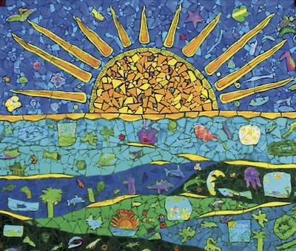
Debrah C. Sickler-Voigt ©, Author
www.arted.us

Routledge

